**Goal**: To define De Lune’s mission statement

**Why**: As we build the team, grow our products and presence, and devote more hours to De Lune, we need to be aligned and rally around a clear, coordinated mission.

**Description**: An organization’s mission statement should clearly communicate what it is that they do. Many mission statements succumb to an overuse of words in general, but especially jargon. Good mission statements should be ***clear, concise, and useful***. Some might also add “inspiring” to the list of descriptors. We don’t altogether disagree, but we find that including this as an upfront criteria often ends up with a Frankenstein that is a part mission, part [vision statement](https://topnonprofits.com/examples/vision-statements/) (desired end-state), and almost always too long.

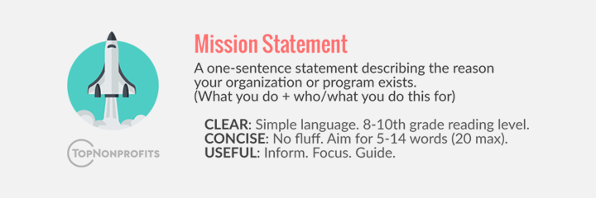

**Examples**: See some good examples [here](https://topnonprofits.com/examples/nonprofit-mission-statements/).

**Steps to Execution**: This doc is a central repository for our mission statement ideas. Our next goal should be to determine a [Vision Statement](https://www.clearvoice.com/blog/difference-between-mission-vision-statement-examples/).

**Courtney**

I think we support and improve the health of those who menstruate. This encompasses physical/mental/holistic health. We do this directly with our products/services, and indirectly with research funding and education

To me, transforming the menstrual experience from a life hinderance to an opportunity for self-care/comfort appeals to the physical/mental/holistic health piece

*Reiterating on Mimi’s reiteration of Ryan’s:*

*De Lune is fighting for a menstruation-friendly world by creating products and services that support health and improve the lives of people with periods.*

**Kai**

processing...

**Ryan**

Mission: De Lune is fighting for a menstruation-friendly world by creating products and services that support and improve the menstrual experience.

Vision: A world with complete awareness, education, and relief for all menstruators.

**Dino**

De Lune builds products and services that transform the menstrual experience.

**Mimi**

for our mission statement - we should maybe frame it as products/services "for people with periods" rather than "products for the menstrual experience". our third product is slated to be something that does not directly impact the menstrual experience, but supports people on bc pills (i.e. people with periods)

Iterating on Ryan’s:

De Lune is fighting for a menstruation-friendly world by creating products and services that support and improve **the lives of people with periods**.

Core Values brainstorm:

1. Empowerment (helping people take ownership of their periods & make intentional choices, instead of acting out of desperation)
2. Self-love (helping people care for their cycles in a way that feels good to them, doesn’t involve shame or dread)
3. Inclusion (expanding the conversation about periods to include as many different voices as possible and helping address the unique needs of each group affected - women, men, girls, boys, non-binary folks, trans menstruators, diabetic people, queer folks, people of all body types, races, ages, etc, etc, etc)
4. Education (sharing useful information about menstruation, and other related health issues, with those who need it)
5. Holism (addressing the health of the whole person as a system)
6. Safety (providing products/services that do not create more negative side effects)
7. Sustainability (creating as little waste as possible for the long-term health of the planet, and valuing the long-term health of our customers over the “bandaid” solutions)
8. Egalitarianism (helping marginalized groups, especially women with periods, to have equal rights and opportunities - like not missing school due to cramps!! - and addressing gender equality issues in scientific research)
9. Evidence-based approach? (something that gets at the fact that we value scientific research when crafting our products)